COFFEE SHOP SALES PROJECT

**MY SQL QUERIES**

The dataset is called "Coffee." The first steps involve data cleaning and formatting specific columns properly. Once the data is organized, we can perform queries related to the business problems.

create database coffee_database;

use coffee_database;

select*from coffee;

describe coffee;

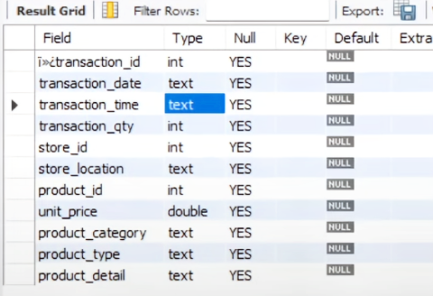

The transaction_date and transaction_time columns are currently in text format, but they need to be converted to Date and Time formats. I’ll use SQL queries to change them into the correct Date and Time format.

1.For ( transaction_date).

-- Step 1: Add a new column with the DATE type

ALTER TABLE coffee

ADD COLUMN new_transaction_date DATE;

-- Step 2: Update the new column with converted values

UPDATE coffee

SET new_transaction_date = STR_TO_DATE(transaction_date, '%Y-%m-%d');

-- Step 3: Drop the old column

ALTER TABLE coffee

DROP COLUMN transaction_date;

-- Step 4: Rename the new column to the original column name

ALTER TABLE coffee

RENAME COLUMN new_transaction_date TO transaction_date;

2.For (transaction_time).

-- Step 1: Add a new column with the TIME type

ALTER TABLE coffee

ADD COLUMN new_transaction_time TIME;

-- Step 2: Update the new column with converted values

UPDATE coffee

SET new_transaction_time = STR_TO_DATE(transaction_time, '%H:%i:%s');

-- Step 3: Drop the old column

ALTER TABLE coffee

DROP COLUMN transaction_time;

-- Step 4: Rename the new column to the original column name

ALTER TABLE coffee

RENAME COLUMN new_transaction_time TO transaction_time;

DESCRIBE coffee;

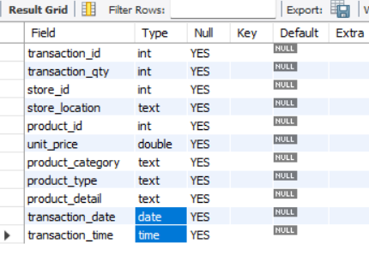

NOTE- Both columns are now displayed in the proper format.

3. Rename the transaction_id.

select*from coffee;

alter table coffee

change column ï»¿transaction_id transaction_id int;

4. Now solve the business Problems statements.

**TOTAL SALES ANALYSIS**

**• Calculate the total sales for each respective month.**

select*from coffee;

select sum(unit_price * transaction_qty) as total_sales

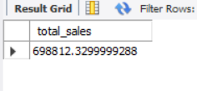from coffee;

select sum(unit_price * transaction_qty) as total_sales

from coffee

where

month(transaction_date) = 5;

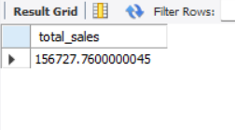

select round(sum(unit_price * transaction_qty)) as total_sales

from coffee

where

month(transaction_date) = 3;

**• Determine the month-on-month increase or decrease in sales.**

SELECT

MONTH(transaction_date) AS month,

ROUND(SUM(unit_price * transaction_qty)) AS total_sales,

(SUM(unit_price * transaction_qty) - LAG(SUM(unit_price * transaction_qty), 1) -- month sales different

OVER (ORDER BY MONTH(transaction_date))) / LAG(SUM(unit_price * transaction_qty), 1) -- divison by PM sales

OVER (ORDER BY MONTH(transaction_date)) * 100 AS mom_increase_percentage -- convert in percentage

FROM * coffee

WHERE

MONTH(transaction_date) IN (4, 5) -- for months of April and May

GROUP BY

MONTH(transaction_date)

ORDER BY

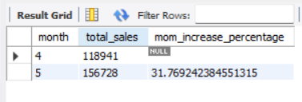 MONTH(transaction_date);

**• Calculate the difference in sales between the selected month and the previous month.**

Ans= 31.76%

**TOTAL ORDER’S ANALYSIS**

**• Calculate the total number of orders for each respective month.**

select count(transaction_id) as total_orders

from coffee

where

month(transaction_date)=3;

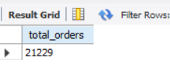

select count(transaction_id) as total_orders

from coffee

where

month(transaction_date) = 5;

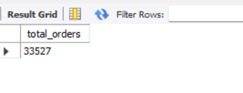

**• Determine the month-on-month increase or decrease in the number of orders.**

SELECT

MONTH(transaction_date) AS month,

ROUND(count(unit_price * transaction_id)) AS total_sales,

(SUM(unit_price * transaction_id) - LAG(SUM(unit_price * transaction_id), 1) -- month sales different

OVER (ORDER BY MONTH(transaction_date))) / LAG(SUM(unit_price * transaction_id), 1) -- divison by PM sales

OVER (ORDER BY MONTH(transaction_date)) * 100 AS mom_increase_percentage -- convert in percentage

FROM

coffee

WHERE

MONTH(transaction_date) IN (4, 5) -- for months of April and May

GROUP BY

MONTH(transaction_date)

ORDER BY

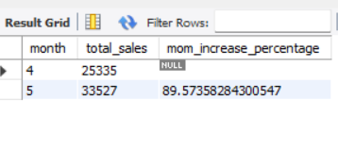 MONTH(transaction_date);

**• Calculate the difference in the number of orders between the selected month and the previous month.**

Ans- 89.57%

**TOTAL QUANTITY SOLD ANALYSIS**

**• Calculate the total quantity sold for each respective month.**

**• Calculate the difference in the total quantity sold between the selected month and the previous month.**

SELECT SUM(transaction_qty) as Total_Quantity_Sold

FROM coffee

WHERE

MONTH(transaction_date) = 5; -- for month of (CM-May)

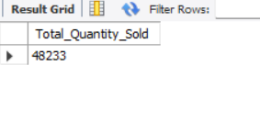

SELECT SUM(transaction_qty) as Total_Quantity_Sold

FROM coffee

WHERE MONTH (transaction_date) = 6 -- for month of (CM-May)

**• Determine the month-on-month increase or decrease in the total quantity sold.**

SELECT

MONTH(transaction_date) AS month,

ROUND(SUM(transaction_qty)) AS total_quantity_sold,

(SUM(transaction_qty) - LAG(SUM(transaction_qty), 1)

OVER (ORDER BY MONTH(transaction_date))) / LAG(SUM(transaction_qty), 1)

OVER (ORDER BY MONTH(transaction_date)) * 100 AS mom_increase_percentage

FROM

coffee

WHERE

MONTH(transaction_date) IN (4, 5) -- for April and May

GROUP BY

MONTH(transaction_date)

ORDER BY

MONTH(transaction_date);

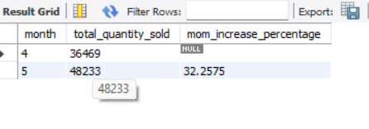

**5. CALENDAR TABLE – DAILY SALES, QUANTITY and TOTAL ORDERS**

SELECT

SUM(unit_price * transaction_qty) AS total_sales,

SUM(transaction_qty) AS total_quantity_sold,

COUNT(transaction_id) AS total_orders

FROM

coffee

WHERE

transaction_date = '2023-05-18'; -- --For 18 May 2023

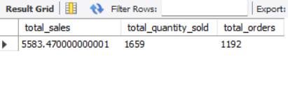

**--If you want to get exact Rounded off values then use below query to get the result:**

SELECT

CONCAT(ROUND(SUM(unit_price * transaction_qty) / 1000, 1),'K') AS total_sales,

CONCAT(ROUND(COUNT(transaction_id) / 1000, 1),'K') AS total_orders,

CONCAT(ROUND(SUM(transaction_qty) / 1000, 1),'K') AS total_quantity_sold

FROM

coffee

WHERE

transaction_date = '2023-05-18'; -- For 18 May 2023

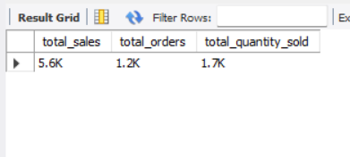

**--DAILY SALES FOR MONTH SELECTED.**

SELECT

DAY(transaction_date) AS day_of_month,

ROUND(SUM(unit_price * transaction_qty),1) AS total_sales

FROM

coffee

WHERE

MONTH(transaction_date) = 5 -- Filter for May

GROUP BY

DAY(transaction_date)

ORDER BY

DAY(transaction_date);

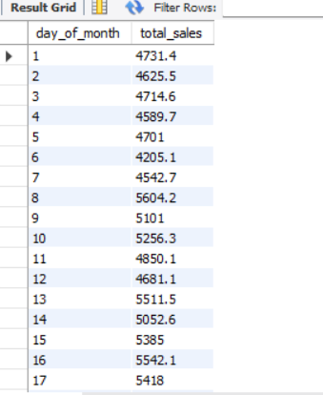

**-- COMPARING DAILY SALES WITH AVERAGE SALES – IF GREATER THAN “ABOVE AVERAGE” and LESSER THAN “BELOW AVERAGE”**

SELECT

day_of_month,

CASE

WHEN total_sales > avg_sales THEN 'Above Average'

WHEN total_sales < avg_sales THEN 'Below Average'

ELSE 'Average'

END AS sales_status,

total_sales

FROM (

SELECT

DAY(transaction_date) AS day_of_month,

SUM(unit_price * transaction_qty) AS total_sales,

AVG(SUM(unit_price * transaction_qty)) OVER () AS avg_sales

FROM

coffee

WHERE

MONTH(transaction_date) = 5 -- Filter for May

GROUP BY

DAY(transaction_date)

) AS sales_data

ORDER BY

day_of_month;

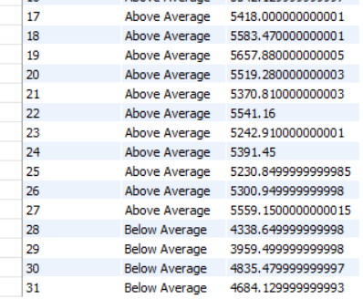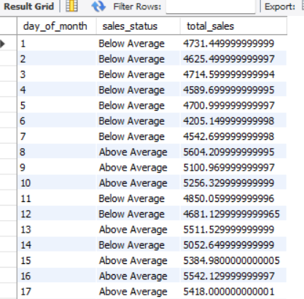

**-- SALES BY WEEKDAY / WEEKEND**

SELECT

CASE

WHEN DAYOFWEEK(transaction_date) IN (1, 7) THEN 'Weekends'

ELSE 'Weekdays'

END AS day_type,

ROUND(SUM(unit_price * transaction_qty),2) AS total_sales

FROM

coffee

WHERE

MONTH(transaction_date) = 5 -- Filter for May

GROUP BY

CASE

WHEN DAYOFWEEK(transaction_date) IN (1, 7) THEN 'Weekends'

ELSE 'Weekdays'

END;

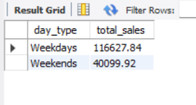

**-- SALES BY STORE LOCATION**

SELECT

store_location,

SUM(unit_price * transaction_qty) as Total_Sales

FROM coffee

WHERE

MONTH(transaction_date) =5

GROUP BY store_location

ORDER BY SUM(unit_price * transaction_qty) DESC;

**-- SALES BY PRODUCT CATEGORY**

SELECT

product_category,

ROUND(SUM(unit_price * transaction_qty),1) as Total_Sales

FROM coffee

WHERE

MONTH(transaction_date) = 5

GROUP BY product_category

ORDER BY SUM(unit_price * transaction_qty) DESC;

**-- SALES BY PRODUCTS (TOP 10)**

SELECT

product_type,

ROUND(SUM(unit_price * transaction_qty),1) as Total_Sales

FROM coffee

WHERE

MONTH(transaction_date) = 5

GROUP BY product_type

ORDER BY SUM(unit_price * transaction_qty) DESC

LIMIT 10;

**-- SALES BY DAY | HOUR**

SELECT

ROUND(SUM(unit_price * transaction_qty)) AS Total_Sales,

SUM(transaction_qty) AS Total_Quantity,

COUNT(*) AS Total_Orders

FROM

coffee

WHERE

DAYOFWEEK(transaction_date) = 3 -- Filter for Tuesday (1 is Sunday, 2 is Monday, ..., 7 is Saturday)

AND HOUR(transaction_time) = 8 -- Filter for hour number 8

AND MONTH(transaction_date) = 5; -- Filter for May (month number 5);

**-- TO GET SALES FROM MONDAY TO SUNDAY FOR MONTH OF MAY**

SELECT

CASE

WHEN DAYOFWEEK(transaction_date) = 2 THEN 'Monday'

WHEN DAYOFWEEK(transaction_date) = 3 THEN 'Tuesday'

WHEN DAYOFWEEK(transaction_date) = 4 THEN 'Wednesday'

WHEN DAYOFWEEK(transaction_date) = 5 THEN 'Thursday'

WHEN DAYOFWEEK(transaction_date) = 6 THEN 'Friday'

WHEN DAYOFWEEK(transaction_date) = 7 THEN 'Saturday'

ELSE 'Sunday'

END AS Day_of_Week,

ROUND(SUM(unit_price * transaction_qty)) AS Total_Sales

FROM

coffee

WHERE

MONTH(transaction_date) = 5 -- Filter for May (month number 5)

GROUP BY

CASE

WHEN DAYOFWEEK(transaction_date) = 2 THEN 'Monday'

WHEN DAYOFWEEK(transaction_date) = 3 THEN 'Tuesday'

WHEN DAYOFWEEK(transaction_date) = 4 THEN 'Wednesday'

WHEN DAYOFWEEK(transaction_date) = 5 THEN 'Thursday'

WHEN DAYOFWEEK(transaction_date) = 6 THEN 'Friday'

WHEN DAYOFWEEK(transaction_date) = 7 THEN 'Saturday'

ELSE 'Sunday'

END;

**-- TO GET SALES FOR ALL HOURS FOR MONTH OF MAY**

SELECT

HOUR(transaction_time) AS Hour_of_Day,

ROUND(SUM(unit_price * transaction_qty)) AS Total_Sales

FROM

coffee

WHERE

MONTH(transaction_date) = 5 -- Filter for May (month number 5)

GROUP BY

HOUR(transaction_time)

ORDER BY

HOUR(transaction_time);

**THE END**